Early Medical Assessment

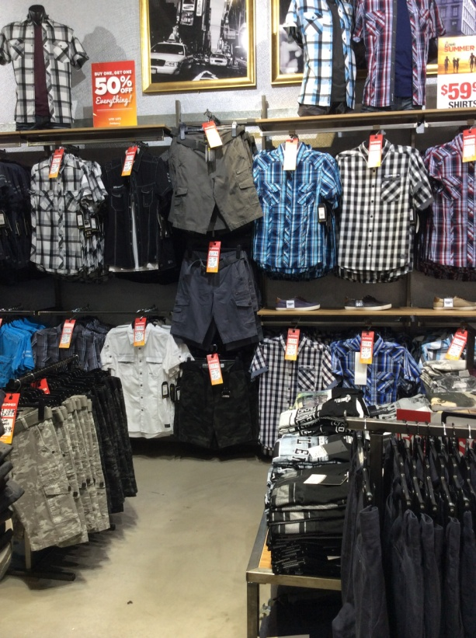
Clothing and Clothing Accessories
Menswear Sales Assistant
SAWIC Code 484001

Clothing and Clothing Accessories
Menswear Sales Assistant
Dear Doctor: This form will take up to 5 minutes to complete. Please review each task the worker undertakes (both picture and written description) and tick whether or not the worker can complete this task. If modification required, please leave comments. Space at the end of this document is available for final comments and recommendations.
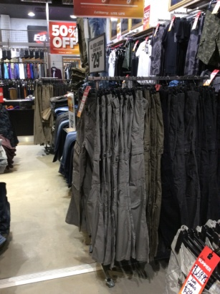 | Customer Service  - Standing and assisting / discussing product with customer  - Handling stock (⅓ - 1kg) on hangers or shelves at varying heights | Doctor Approval  Yes No  Comments:
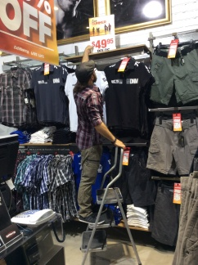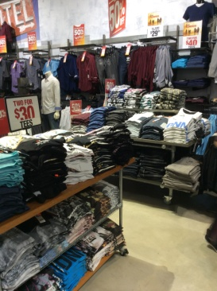  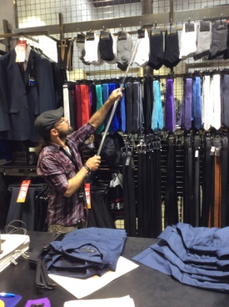 | Handling Stock  - Handling stock and advertising signs (⅓ - 1kg)  - Shelf height varies from floor to approx. 2.4m  - Safety step / ladder and reaching rod may be available  - Folding of stock and placing on shelves, and hanging items on hangers and placing on racks  - Squatting, forward reaching, overhead reaching, grasping, and possibly climbing required. | Doctor Approval  Yes No  Comments:
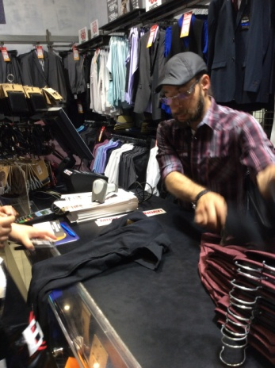 | Process Transaction  - Walking to and standing at front counter  - Grasping and scanning item using a hand-held scanner (hammer grip)  - Using keyboard and computer to record sale whilst standing  - Handling cash or EFT  - Wrapping and bagging item(s) at counter. Fine dexterity required. | Doctor Approval  Yes No  Comments:
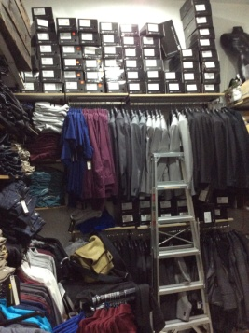 | Recovery of Back-up Stock  - Occasionally retrieve stock from rear storeroom  - Handling and climbing step ladder  - Reaching to remove items from hangers and shelves at varying heights | Doctor Approval  Yes No  Comments:
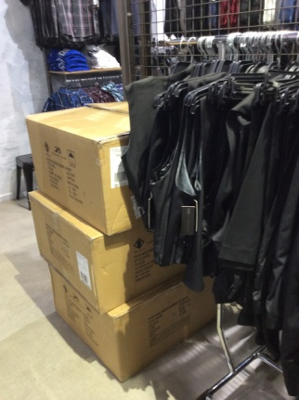 | Processing Bulk Stock and Orders  - Receiving goods at the back of the shop from delivery man (max. weight of boxes 15kg).  - Occasionally lifting boxes  - Unpacking items from boxes  - These tasks involve moving, bending, lifting, grasping, climbing and reaching | Doctor Approval  Yes No  Comments:
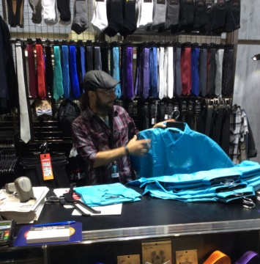 | Re-Merchandising  - Moving merchandise  - Replacing stock  - Folding and applying hangers and hanging stock on store displays requiring grasping and reaching to varying heights. | Doctor Approval  Yes No  Comments:
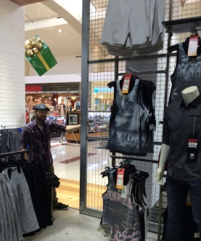 | Daily Tasks (house-keeping)  - Opening the store in the morning and closing the store at end of day (some stores have security door on rollers for easy pulling and pushing)  - Using (pushing/pulling) industrial vacuum cleaner for floors  - Cleaning surfaces and glass | Doctor Approval  Yes No  Comments:
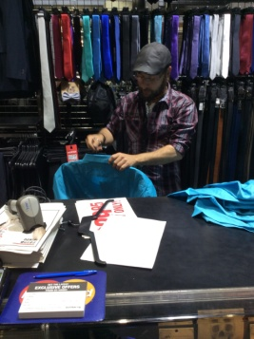 | Preparing Specials  - Preparing specials for the day and placing them on the rack and display tables  - Applying price labels on merchandise whilst standing at counter. Fine dexterity required for labeling | Doctor Approval  Yes No  Comments:
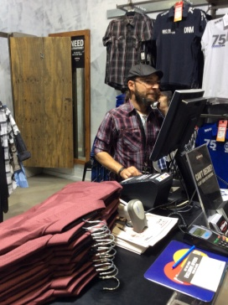 | Administrative Tasks  - Answering phone and responding to queries  - Paper work (occasional hand writing)  - Using computer | Doctor Approval  Yes No  Comments:
Work Capacity Form
Doctor Review (include final comments)

I confirm that in my view, subject to the above comments, the worker is able to perform certain duties detailed in this Early Medical Assessment.
These duties should be reassessed on: |  | Date:

Signature : |  | Date:

Employers Declaration:
I confirm that I/we have reviewed the Doctor’s recommendations and comments. I/we will make suitable changes to make allowances for the Dr’s recommendations.
Signature : |  | Date:

Employees Declaration
My Doctor has discussed their recommendations with me. I have been given the opportunity to participate in this process.
Signature : |  | Date:
For information on completing this form, please contact Business SA on 08 8300 0000.
Disclaimer: This document is published by Business SA with funding from ReturnToWorkSA. All workplaces and circumstances are different and this document should be used as a guide only. It is not diagnostic and should not replace consultation, evaluation, or personal services including examination and an agreed course of action by a licensed practitioner. Business SA and ReturnToWorkSA and their affiliates and their respective agents do not accept any liability for injury, loss or damage arising from the use or reliance on this document. The copyright owner provides permission to reproduce and adapt this document for the purposes indicated and to tailor it (as intended) for individual circumstances. (C) 2016 ReturnToWorkSA

