Early Medical Assessment
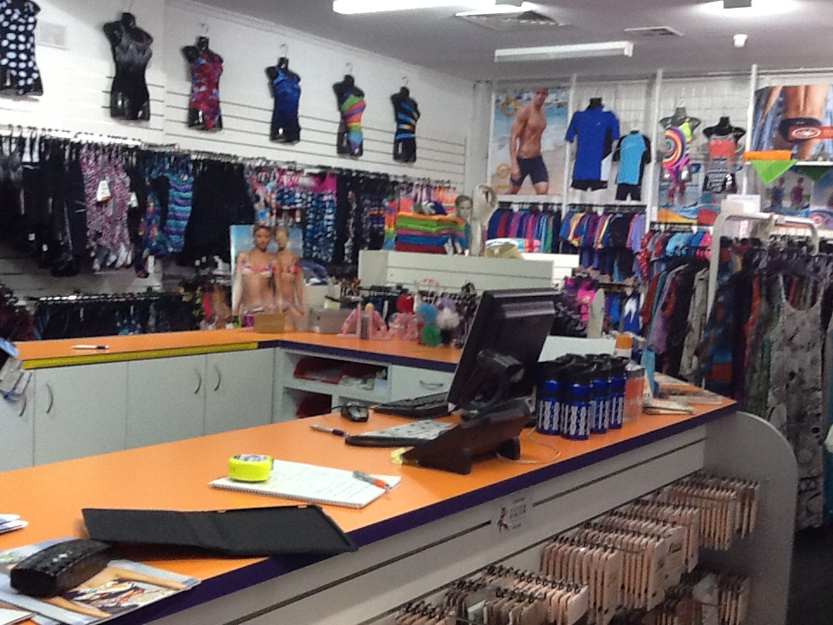
Clothing and Clothing Accessories
Sportswear Retail Sales Assistant
Clothing and Clothing Accessories SAWIC Code 484001

Clothing and Clothing Accessories
Sportswear Retail Sales Assistant
Dear Doctor: This form will take up to 5 minutes to complete. Please review each task the worker undertakes (both picture and written description) and tick whether or not the worker can complete this task. If modification required, please leave comments. Space at the end of this document is available for final comments and recommendations.
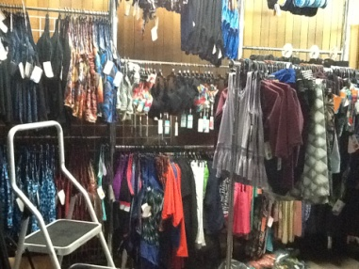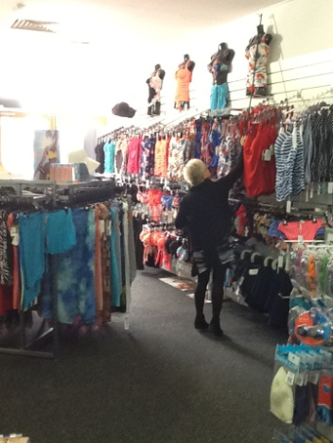 | Customer Service  - Handling stock (⅓ - 1kg), includes amongst others  - Swimwear/sportswear  - Dance wear  - Assist customer (e.g. with fetching new garments or shoe fitting)  - Repeated squatting and getting up, bending, reaching, using steps/ladders in order to fetch other alternatives for the customer (as appropriate) | Doctor Approval  Yes No  Comments:
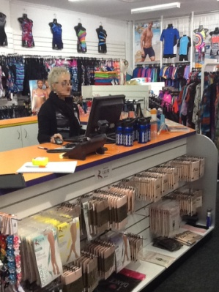 | Process Transaction  - Standing at front counter  - Discussing product with customer  - Scanning item(s)  - Handling cash or EFT  - Wrapping and bagging item(s) at counter  - Fine motor skills and forward reaching required
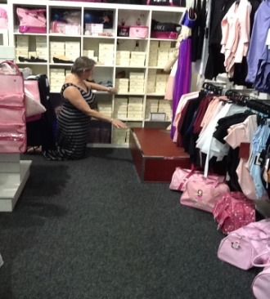 | Handling Stock  - Handling stock on shelves (floor level to 1.8m high)  - Loose or boxed items, e.g. clothing or shoes (max.1.0kg)  - Wall hangers / racks may be at various heights  - Repeated forward reaching, and reaching between floor level (squatting) and overhead heights  - Grasping of product  Step stool and ladder may be available | Doctor Approval  Yes No  Comments:
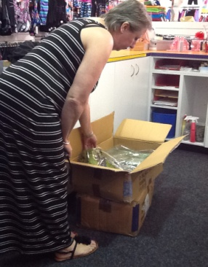 | Processing Bulk Stock and Orders  - Receiving delivered goods at front counter  - Unpacking boxes and shelving / hanging stock  - involves constant bending, reaching and moving | Doctor Approval  Yes No  Comments:
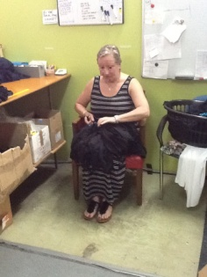 | Mending  - Mending garments by hand at the back of the shop (when time allows). Fine dexterity required | Doctor Approval  Yes No  Comments:
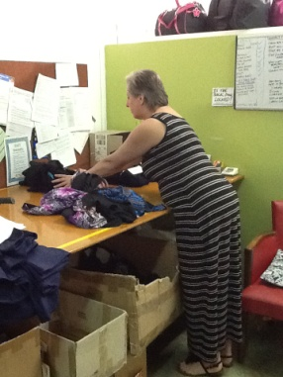 | Sorting  - Sorting mended garments on work bench at the back of the shop (when time allows) | Doctor Approval  Yes No  Comments:
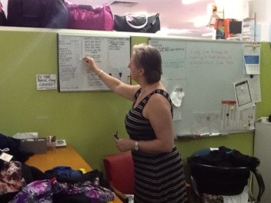 | Logging Jobs  - Keeping a log of finished jobs (i.e. garments mended) on the whiteboard | Doctor Approval  Yes No  Comments:
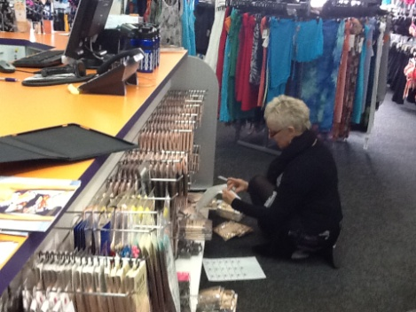 | Other Daily Tasks  - Labeling merchandise  - Replacing stock on shelves and on hangers (varying heights)  - Tidying up  - Cleaning windows  - Vacuuming / sweeping / dusting | Doctor Approval  Yes No  Comments:
Work Capacity Form
Doctor Review (include final comments)

I confirm that in my view, subject to the above comments, the worker is able to perform certain duties detailed in this Early Medical Assessment.
These duties should be reassessed on: |  | Date:

Signature : |  | Date:

Employers Declaration:
I confirm that I/we have reviewed the Doctor’s recommendations and comments. I/we will make suitable changes to make allowances for the Dr’s recommendations.
Signature : |  | Date:

Employees Declaration
My Doctor has discussed their recommendations with me. I have been given the opportunity to participate in this process.
Signature : |  | Date:
For information on completing this form, please contact Business SA on 08 8300 0000.
Disclaimer: This document is published by Business SA with funding from ReturnToWorkSA. All workplaces and circumstances are different and this document should be used as a guide only. It is not diagnostic and should not replace consultation, evaluation, or personal services including examination and an agreed course of action by a licensed practitioner. Business SA and ReturnToWorkSA and their affiliates and their respective agents do not accept any liability for injury, loss or damage arising from the use or reliance on this document. The copyright owner provides permission to reproduce and adapt this document for the purposes indicated and to tailor it (as intended) for individual circumstances. (C) 2016 ReturnToWorkSA

