Early Medical Assessment

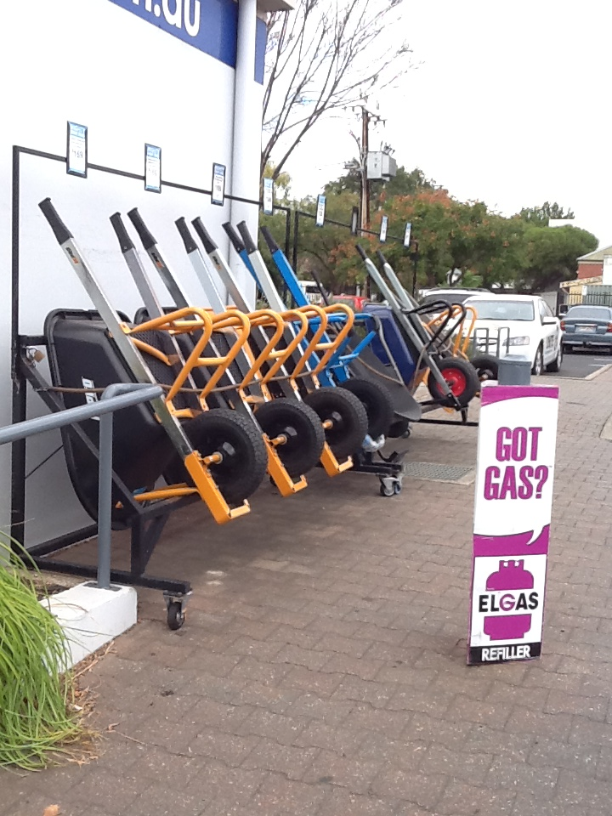

Domestic Hardware and Homeware Retailing
Supervisor

Domestic Hardware and Homeware Retailing
Supervisor
Dear Doctor: This form will take up to 5 minutes to complete. Please review each task the worker undertakes (both picture and written description) and tick whether or not the worker can complete this task. If modification required, please leave comments. Space at the end of this document is available for final comments and recommendations.
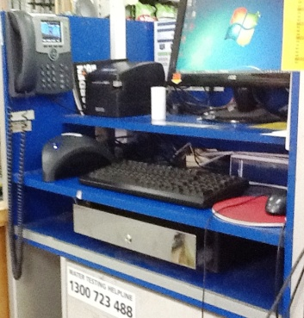 | General Duties  - Opening and closing the store each day  - Unlocking doors  - Placing cash draw at front counter each morning for sales assistant | Doctor Approval  Yes No  Comments:
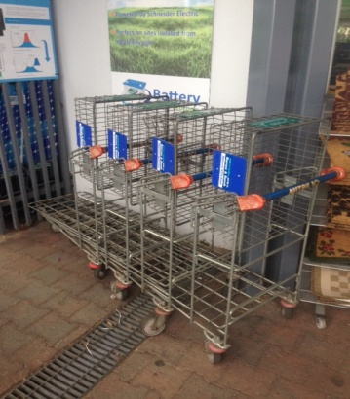 | Store Responsibilities  - Each morning moving (lifting, carrying, pushing) appropriate stock from shop to front of store and driveway  - Each evening moving in stock from front of store  - Pushing customer trolleys outside for customers easy access | Doctor Approval  Yes No  Comments:
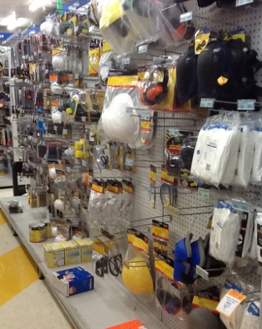 | Customer Service  - Constant standing whilst providing customers with fast, efficient, friendly and knowledgeable service  - Answering customer queries and complaints in a courteous, efficient manner  - Understanding of the products sold and their suitable application  - Merchandising stock according to company guidelines | Doctor Approval  Yes No  Comments:
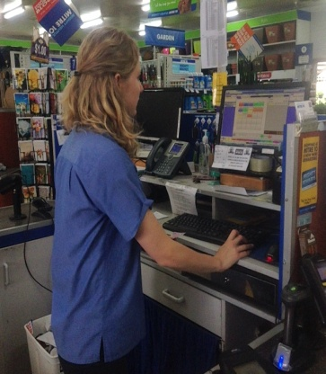 | Staff / Supervisory  - Ensuring the work, health and safety of each employee and customer that enters the business  - Organising staff to appropriate areas | Doctor Approval  Yes No  Comments:
Work Capacity Form
Doctor Review (include final comments)

I confirm that in my view, subject to the above comments, the worker is able to perform certain duties detailed in this Early Medical Assessment.
These duties should be reassessed on: |  | Date:

Signature : |  | Date:

Employers Declaration:
I confirm that I/we have reviewed the Doctor’s recommendations and comments. I/we will make suitable changes to make allowances for the Doctor’s recommendations.
Signature : |  | Date:

Employees Declaration
My Doctor has discussed their recommendations with me. I have been given the opportunity to participate in this process.
Signature : |  | Date:
For information on completing this form, please contact Business SA on 08 8300 0000.
Disclaimer: This document is published by Business SA with funding from ReturnToWorkSA. All workplaces and circumstances are different and this document should be used as a guide only. It is not diagnostic and should not replace consultation, evaluation, or personal services including examination and an agreed course of action by a licensed practitioner. Business SA and ReturnToWorkSA and their affiliates and their respective agents do not accept any liability for injury, loss or damage arising from the use or reliance on this document. The copyright owner provides permission to reproduce and adapt this document for the purposes indicated and to tailor it (as intended) for individual circumstances. (C) 2016 ReturnToWorkSA

