Early Medical Assessment

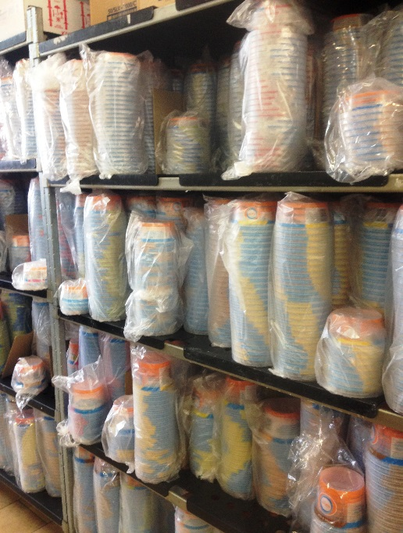

Fish and Takeaway Retailing
Packing Tubs

Fish and Takeaway Retailing
Packing Tubs
Dear Doctor: This form will take up to 5 minutes to complete. Please review each task the worker undertakes (both picture and written description) and tick whether or not the worker can complete this task. If modification required, please leave comments. Space at the end of this document is available for final comments and recommendations.
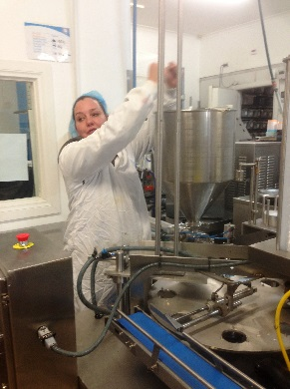  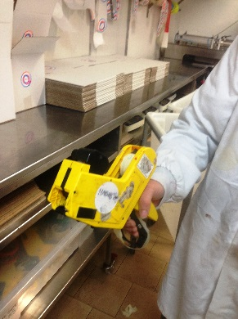  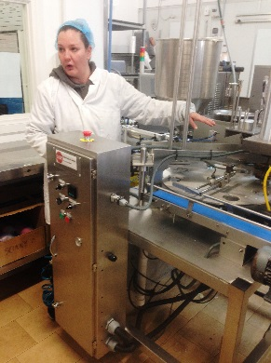  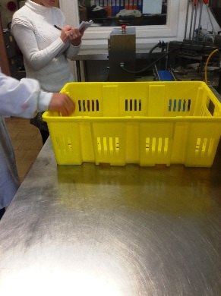  1863  1858  1859  1862 | Filling Tubs  - Pushing bucket trolley with 5kg bags of yoghurt to bench.  - Filling hoppers with 5kg bags of yoghurt requiring bilateral overhead lifting to pour into hopper.  - Collecting tubs / cups from back storeroom and placing in machine.  - Placing tubs / cups on bench and dating with date gun (hammer grip).  - Filling cups / tubs with yoghurt with machine and placing on conveyor belt.  - Second worker grasps full cup off conveyor and places in crate on bench.  - Cups are lidded automatically by machine; tubs are lidded manually. | Doctor Approval  Yes No  Comments:
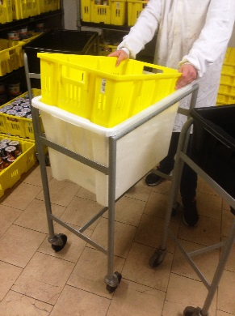  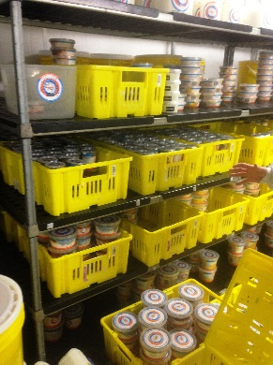 | Shelving  - Carrying full crate to cool room and placed on shelves.  - Rotation of stock as required involving lift of tubs and placing back on shelves in different order. | Doctor Approval  Yes No  Comments:
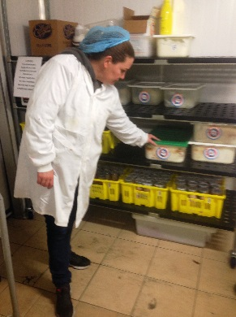  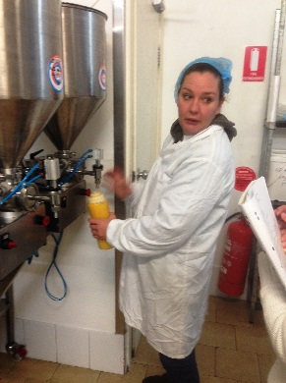 | Toppings  - Refilling hoppers for fruit toppings daily from 19L bag or 3.5L tin cans. Bilateral overhead reach required to pour into hopper. Step can be used to reduce reaching.  - Placing dry ingredients on overhead shelves in boxes. These are only accessed occasionally to re-stock.  - Puree bottles are refilled using a scoop with the dominant hand. | Doctor Approval  Yes No  Comments:
Work Capacity Form
Doctor Review (include final comments)

I confirm that in my view, subject to the above comments, the worker is able to perform certain duties detailed in this Early Medical Assessment.
These duties should be reassessed on: |  | Date:

Signature : |  | Date:

Employers Declaration:
I confirm that I/we have reviewed the Doctor’s recommendations and comments. I/we will make suitable changes to make allowances for the Dr’s recommendations.
Signature : |  | Date:

Employees Declaration
My Doctor has discussed their recommendations with me. I have been given the opportunity to participate in this process.
Signature : |  | Date:
For information on completing this form, please contact Business SA on 08 8300 0000.
Disclaimer: This document is published by Business SA with funding from ReturnToWorkSA. All workplaces and circumstances are different and this document should be used as a guide only. It is not diagnostic and should not replace consultation, evaluation, or personal services including examination and an agreed course of action by a licensed practitioner. Business SA and ReturnToWorkSA and their affiliates and their respective agents do not accept any liability for injury, loss or damage arising from the use or reliance on this document. The copyright owner provides permission to reproduce and adapt this document for the purposes indicated and to tailor it (as intended) for individual circumstances. (C) 2016 ReturnToWorkSA

